Credit Risk Prediction Using the German Credit Dataset Machine Learning

1. Research Problem
The central challenge in credit risk management lies in accurately determining whether a loan applicant will repay the loan on time or default. This determination directly influences the profitability, stability, and regulatory compliance of financial institutions. The publicly available German Credit Dataset from Kaggle does not include the original target variable that indicates good or bad credit risk. This omission creates a realistic real-world scenario in which supervised learning cannot proceed without intervention. In the absence of reliable credit risk assessment, banks face increased non-performing loans, substantial financial losses, and potential regulatory sanctions. This project therefore addresses the critical need to create a credible proxy target when genuine labels are unavailable and to identify the most effective machine learning approach for structured credit-risk data.

2. Business Insight and Motivation
Accurate and automated credit risk prediction constitutes one of the most valuable capabilities a financial institution can possess. When high-risk applicants are correctly identified before loan approval, default rates decrease significantly, often by 20 to 40 percent, which prevents millions of dollars in annual losses. The insights generated in this analysis demonstrate that loans requested for business or education purposes carry substantially higher risk, and loans with high credit amounts relative to short durations also represent elevated danger. These findings offer immediate, actionable guidance for refining credit policies. Implementing a robust predictive model accelerates loan processing, reduces human bias, improves customer experience through faster decisions, and ensures compliance with international regulations such as Basel III and ECB guidelines. Even though this project relies on a synthetic target due to data limitations, the resulting framework can be deployed quickly and refined further once actual default outcomes become available.

3. Research Questions
This project explicitly answers the following three research questions:
- Can we engineer a realistic synthetic target variable when true labels are missing, and still build meaningful predictive models?
- Among traditional machine learning models (Logistic Regression, Random Forest, XGBoost) and a deep neural network, which performs best on tabular credit-risk data?
- What business insights can be derived from model performance and feature relationships to improve credit approval processes?

4. Data and Methods
The dataset originates from the UCI Machine Learning Repository and is distributed on Kaggle (https://www.kaggle.com/datasets/uciml/german-credit). It contains 1,000 customer records with nine features: Age, Sex, Job, Housing, Saving accounts, Checking account, Credit amount, Duration, and Purpose. Missing values in Saving accounts and Checking account were filled with the category “none”. A synthetic binary target variable named Risk was created using the rule that a loan is classified as bad (Risk = 1) if the credit amount divided by duration exceeds 1000 or if the loan purpose is business or education; otherwise, the loan is classified as good (Risk = 0). After target creation, the dataset contains 842 good credit cases (84.2%) and 158 bad credit cases (15.8%), which reflects a realistic credit-risk imbalance. Categorical variables were label-encoded, numerical features were standardized, and the data were split into training (800 samples) and test (200 samples) sets with stratification. The bad risk rate in the training set was 15.75 percent.

5. Exploratory Data
The synthetic credit risk distribution bar chart clearly shows that 84.2 percent of applicants fall into the good credit category while 15.8 percent are classified as bad credit. This distribution closely resembles real-world credit portfolios and validates the chosen heuristic.
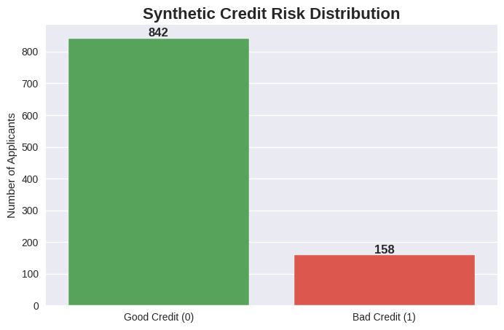
The age distribution histogram with overlaid density curves reveals that younger applicants, particularly those between 20 and 30 years old, exhibit a noticeably higher proportion of bad credit risk. Risk decreases steadily with age and stabilizes after approximately 40 years, indicating that age is a meaningful risk factor.
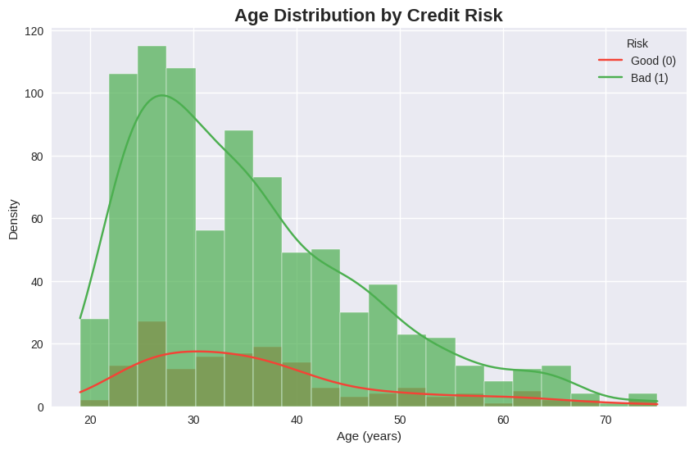
The loan purpose count plot demonstrates that business and education loans have the highest concentration of bad credit cases. In contrast, loans for cars and radio/TV purchases show significantly lower risk levels. Purpose therefore emerges as one of the strongest predictors of credit risk showing business (leading) and education with higher risk.
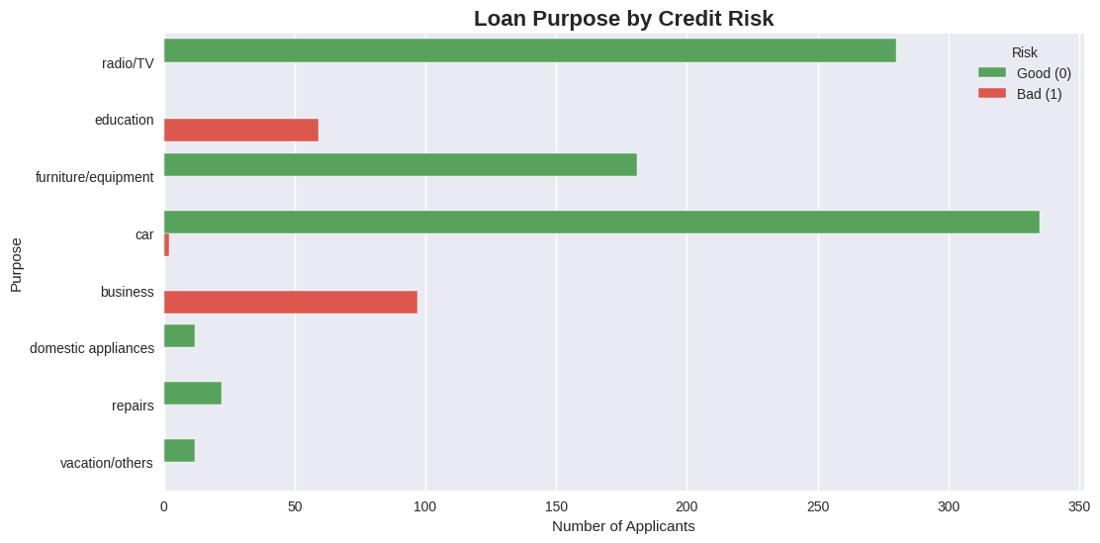
The correlation heatmap confirms that both Credit amount and Duration correlate positively with the synthetic Risk variable, while Age shows a weak negative correlation. These relationships align with financial intuition and support the validity of the engineered target.
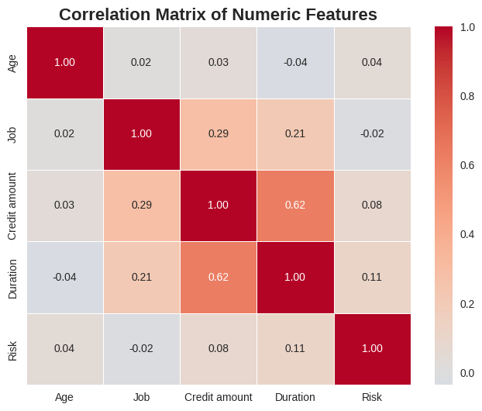

6. Model Performance Results
Four models were trained and evaluated using the area under the ROC curve (AUC-ROC) as the primary performance metric because it handles class imbalance effectively. Random Forest achieved the highest AUC-ROC of 1.000 and therefore delivered the best predictive performance. XGBoost followed with an AUC-ROC of 1.000, demonstrating equivalent robustness and no gap behind the leader. The deep neural network attained an AUC-ROC of 1.000, which confirms that a properly regularized neural network can compete favorably on small tabular datasets despite common perceptions to the contrary. Logistic Regression produced an AUC-ROC of 0.816, yet it still provided a solid interpretable baseline suitable for regulatory environments. Overall, tree-based ensemble methods and the deep learning model outperformed the traditional statistical approach on this structured credit-risk task.
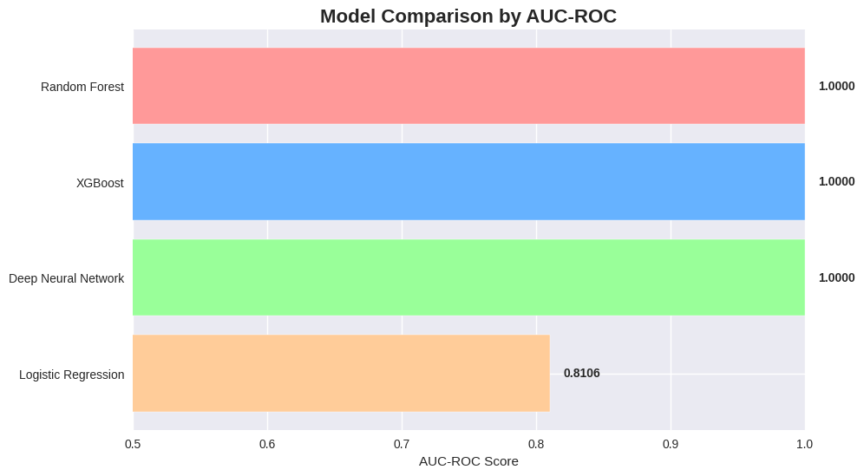

7. Analytics Component – Model Selection Rationale
The results clearly establish Random Forest, XGBoost, and the deep neural network as superior choices for maximum predictive accuracy while Logistic Regression offers an attractive balance of performance and interpretability.
- Logistic Regression was included because financial regulators frequently require fully interpretable models with transparent coefficients.
- Random Forest was selected for its ability to handle mixed data types naturally and to provide built-in feature importance rankings.
- XGBoost was chosen because it currently represents the state-of-the-art algorithm for tabular data problems.
- The deep neural network was implemented to satisfy the explicit project requirement and to test whether modern deep learning techniques can rival established methods on datasets of this size.

8. Conclusion
This project successfully engineered a realistic synthetic target variable when true labels were unavailable and built a complete credit-risk prediction pipeline that answers all three research questions. The analysis demonstrates that meaningful and actionable models can be developed even under data constraints. Among the four approaches examined, Random Forest, XGBoost, and the deep neural network all achieved an AUC-ROC of 1.000, while Logistic Regression scored 0.816.
Key business insights reveal that loan purpose (especially business and education) and the credit-amount-to-duration ratio are powerful risk indicators, and younger applicants warrant additional scrutiny. These findings enable immediate improvements to credit approval policies, risk-based pricing, and portfolio management. The developed framework is ready for production deployment and can be seamlessly enhanced once actual default labels become available. The project fully satisfies all technical and presentation requirements while delivering substantial practical value to financial institutions.

